Problem Specification/Project Plan
Project Title: Practical Benchmarking of Approximate Machine Unlearning for Auditable Enterprise ML Erasure Workflows
Student Name: Niamh Hughes
Student ID: 40299386
Project Supervisor Name: Awais Rauf

- Introduction
  - Project Overview
This project builds and tests a reproducible benchmarking framework for approximate machine unlearning on tabular classification. Under the UK GDPR, simply deleting a record isn't enough if the trained model still reflects its influence. Full retraining removes that influence completely but is costly, while approximate methods are cheaper but their effectiveness and privacy properties aren't well understood for tabular data. This project compares Full Retraining, Retain-Set Fine-Tuning, Gradient Ascent Unlearning and SISA across three tabular datasets, each under two GDPR-motivated deletion scenarios, with the aim of producing a research artefact that supports companies in discussing auditable erasure workflows with enterprise clients.
1.2 Objectives
To investigate existing machine unlearning techniques and their role in supporting data deletion requirements within machine learning systems.
To implement and evaluate Full Retraining, Retain-Set Fine-Tuning, Gradient Ascent Unlearning and SISA on tabular classification models.
To evaluate each method using AUROC and F1 (utility), prediction agreement with a retrained baseline (similarity), MIA (privacy) and runtime (efficiency).
To analyse the trade-offs between utility, privacy preservation and computational cost across multiple datasets.
To base the two deletion scenarios on specific parts of GDPR: Article 17 (right to erasure) for the consent-withdrawal scenario, and Article 5(1)(e) (storage limitation) for the retention-expiry scenario.

- Problem Specification
2.1 What is Machine Unlearning?
Cao and Yang were the first to formalise this area, defining the problem as building "forgetting systems, capable of completely forgetting certain data and its lineage" [1] - not just the data point itself, but everything the model later derived from it. Later work refines this into a sharper technical definition: machine unlearning is "the process of removing the influence of specific training data from a model... such that the updated model behaves as if the removed data point had never been used during training" [4]. This second definition is the one used throughout this project, as it gives a concrete target: the unlearned model should be behaviourally indistinguishable from one that was never trained on the forgotten data.
The literature splits methods into two families. Exact unlearning, such as full retraining, guarantees this behavioural equivalence, since the forgotten data genuinely never contributes to the final model. SISA [4] is often grouped with exact unlearning, since the forgotten data is fully excluded from the shard it belonged to, but the other shards' sub-models were trained alongside it as part of the same ensemble, so it isn't quite exact in the strictest sense. Approximate unlearning methods, such as fine-tuning and gradient ascent, instead start from the original model and try to undo the influence of the forgotten data after the fact - faster, but without the same guarantee. This project's four methods span this spectrum, which is part of why the four evaluation metrics (Section 2.3) are needed: without them, there is no way to tell how close each method actually gets to the exact-unlearning ideal.2.2 GDPR Grounding: From Regulation to Method
As more sectors adopt machine learning, large volumes of personal data are being used to train predictive models, and the UK GDPR places strict obligations on how this data is retained and deleted. Two provisions are used directly to design the deletion scenarios in this project. Article 17(1)(b) gives a data subject the right to erasure where "the data subject withdraws consent on which the processing is based... and where there is no other legal ground for the processing" [19]. This is a request that can come at any time, independent of how long the data has been held, and is the basis for the consent-withdrawal forget set: a random subset of individuals is selected to represent users who have exercised this right. Article 17(1)(a) and Article 5(1)(e) work together to cover the second scenario. Article 17(1)(a) requires erasure where "the personal data are no longer necessary in relation to the purposes for which they were collected" [19], and Article 5(1)(e), the storage limitation principle, requires that personal data is kept "in a form which permits identification of data subjects for no longer than is necessary for the purposes for which the personal data are processed" [20]. The Information Commissioners Office (ICO)[21] is explicit that the UK GDPR sets no fixed time limit for this — it is up to the organisation to define and document a retention period appropriate to its own purpose [20]. This is the basis for the retention-expiry forget set: a simulated 'date captured' field is added to each dataset, a retention period is defined and justified (Section 3, Table 1), and records older than this period become the forget set, regardless of whether anyone has made an individual request.
Table 2 summarises this mapping from regulation to method. In both cases, deleting the raw record is not sufficient on its own: if the trained model still reflects the statistical influence of that record, it may still allow the individual to be re-identified, which arguably breaches Article 5(1)(e) even after the underlying data has been removed. Machine unlearning addresses this gap, but as Xu et al. [7] and the Deep Unlearn benchmark [8] note, evaluation across methods remains inconsistent, particularly for tabular settings relevant to enterprise governance. This project addresses that gap directly, evaluating each unlearning method under both deletion scenarios.
Regulation | Legal requirement | Project method
Art 17(1)(b) – withdrawal of consent | Individual-initiated deletion, independent of time held | Consent-withdrawal forget set: random sample of individuals
Art 17(1)(a) – data no longer necessary; Art 5(1)(e) – storage limitation | Data must be deleted once its justified retention period expires, regardless of individual request | Retention-expiry forget set: 'date captured' field + dataset-specific retention period (Table 1)
Art 5(1)(e) – "permits identification" | The model itself must not allow forgotten records to be re-identified | MIA AUC ≈ 0.5 used as a technical proxy for compliance
Table 2: Mapping from specific GDPR provisions to the deletion scenarios and metrics used in this project.
2.3 Problem Domain
The core challenge is that removing a record from a dataset does not remove its learned influence from the model's weights. Full retraining solves this completely, but is too expensive to run every time a deletion request comes in. Approximate methods reduce this cost, but raise a verification problem: good accuracy on the forget set alone does not prove unlearning has happened, since a model could simply get worse overall rather than genuinely forgetting. Because of this, multiple metrics are needed alongside MIA (Table 2): prediction agreement with a retrained baseline shows how close the unlearned model is to one that never saw the deleted data, and utility metrics (AUROC, F1) and runtime complete the picture. Together, these four measures address the benchmarking gaps identified in [8], and are evaluated separately for both forget sets.

- Research Methods and AI Algorithms
An experimental approach will be used under controlled, reproducible conditions. Three tabular classification datasets were chosen: Adult Income [14], Bank Marketing [16] and Hotel Booking Demand [17]. These differ in size, class balance and feature composition, which tests whether results hold across different tabular settings, and all three contain personal or behavioural data that could realistically be subject to erasure requests. A PyTorch MLP classifier is used as the base model, as it is well suited to tabular data and lets gradient manipulation, fine-tuning and sharding be applied and interpreted without the added complexity of larger architectures. Two deletion scenarios are simulated for each dataset, matching the two legal grounds from Section 2.1. The first, based on Article 17(1)(b), picks a random subset of individuals as a consent-withdrawal forget set. The second, based on Article 5(1)(e), adds a simulated 'date captured' field and applies a dataset-specific retention period (Table 1); any records older than this form the retention-expiry forget set. This means each method is tested against both a user-driven and a policy-driven deletion scenario.
Dataset | Retention Period | Justification
Adult Income | 5–6 years | Employment/financial-history data; standard post-relationship review period.
Bank Marketing | 1–2 years | Direct-marketing contact data; time-bound purpose, periodic consent renewal.
Hotel Booking Demand | 1–2 years post-stay | Booking/guest data; short post-stay window for accounting/disputes.
Table 1: Simulated retention periods used to construct the retention-expiry forget set for each dataset (Article 5(1)(e)).
Four methods will be compared. Full Retraining trains a new model from scratch on the retain set only, and acts as the gold-standard baseline: it gives the strongest guarantee that the deleted data's influence is gone, but at the highest cost. Retain-Set Fine-Tuning continues training the original model on the retain set; it's the cheapest option, but some influence from the forget set may still linger. Gradient Ascent Unlearning pushes the model's loss up on the forget set to actively disrupt what it learned from those records; this should forget more thoroughly than fine-tuning, but risks hurting performance on the retain set if it isn't carefully controlled. SISA [4] splits the training data into shards and retrains only the shards affected by a deletion, which is the most principled approach on paper, though its benefits may be smaller at the scale of these datasets. All four methods will be assessed on the same four dimensions: utility (AUROC, F1), how closely they match a retrained baseline (prediction agreement), privacy (MIA) and efficiency (runtime).
"Removing" the forget set means something different for each method, and Table 3 makes this explicit, since it is the basis for the differences expected in Section 4.
Method | What "removing" the forget set means mechanically
Full Retraining | Forget set excluded entirely from training data; a new model is trained from scratch on the retain set only.
Retain-Set Fine-Tuning | Forget set excluded from further training only; its earlier contribution to the model's starting weights remains.
Gradient Ascent | Forget set is used actively: gradients computed on it are applied in reverse to push its prior influence out of the model.
SISA | Forget set determines which shard(s) are retrained; only the affected shard's sub-model is rebuilt, the rest are untouched.
Table 3: Operational definition of "removal" for each unlearning method.
- Anticipated Results
This project will produce a comparison of all four methods, across all three datasets and both deletion scenarios. Retain-Set Fine-Tuning is expected to be the fastest but forget the least, since nothing in the method directly targets the forget set's influence. Gradient Ascent Unlearning should bring the MIA score down further, possibly at some cost to utility. SISA is expected to give the best balance between forgetting and utility by design, though its runtime advantage may be small at this scale. Full Retraining sets the upper bound for both forgetting and similarity to a clean retrained model. The retention-expiry scenario may turn out harder to forget cleanly than the consent-withdrawal one, as records past their retention date could share patterns that are spread more broadly across the model. The main aim is not to find one method that wins overall, but to understand when each method gives enough evidence of forgetting to be trusted in an enterprise governance setting.
Further on this, the two scenarios suggest different open challenges for LLMs. The consent-withdrawal scenario maps to Article 17(1)(b) – despite being studied, it's hard to verify a 'forgotten' element is truly gone, as it can resurface with different prompting. The retention-expiry scenario maps onto Article 5(1)(e) – this is straightforward in tabular data, but for an LLM there's no equivalent operation, since the model has no rows or dates to filter by. Table 3's four definitions of 'removal' could be a useful starting point for thinking about what either of these would mean for an LLM in future work.

- Project Plan and Timeline
See Appendix B

- Risk Management
The main risks are SISA's added implementation complexity (mitigated by building and validating the other three methods first, following Bourtoule et al. [4] with small shard counts), the difficulty of proving unlearning has occurred (mitigated by using all four metrics in Table 2 together rather than relying on accuracy alone), SISA's efficiency benefits being less visible at this dataset scale (mitigated by interpreting results in the context of the chosen datasets and model), and local hardware limits for repeated experiments across two scenarios and three datasets (mitigated by using Azure VMs via ISx4 where needed, see Appendix A).
- References:
[1] Y. Cao and J. Yang, "Towards Making Systems Forget with Machine Unlearning," in 2015 IEEE Symposium on Security and Privacy (SP), San Jose, CA, USA, 2015, pp. 463–480.
[2] A. Ginart, M. Y. Guan, G. Valiant and J. Zou, "Making AI Forget You: Data Deletion in Machine Learning," in Advances in Neural Information Processing Systems (NeurIPS 2019), vol. 32, 2019, pp. 3513–3526.
[3] A. Golatkar, A. Achille and S. Soatto, "Eternal Sunshine of the Spotless Net: Selective Forgetting in Deep Networks," in Proceedings of the IEEE/CVF Conference on Computer Vision and Pattern Recognition (CVPR), 2020, pp. 9304–9312.
[4] L. Bourtoule, V. Chandrasekaran, C. A. Choquette-Choo, H. Jia, A. Travers, B. Zhang, D. Lie and N. Papernot, "Machine Unlearning," in 2021 IEEE Symposium on Security and Privacy (SP), 2021, pp. 141–159.
[5] S. Neel, A. Roth and S. Sharifi-Malvajerdi, "Descent-to-Delete: Gradient-Based Methods for Machine Unlearning," in Algorithmic Learning Theory (ALT), 2021.
[6] A. Golatkar, A. Achille, A. Ravichandran and S. Soatto, "Mixed-Privacy Forgetting in Deep Networks," arXiv preprint arXiv:2003.10933, 2021.
[7] J. Xu, Y. Wang, Y. Wang et al., "Machine Unlearning: A Survey," ACM Computing Surveys, 2024.
[8] X. F. Cadet, A. Borovykh, M. Malekzadeh, S. Ahmadi-Abhari and H. Haddadi, "Deep Unlearn: Benchmarking Machine Unlearning," arXiv preprint arXiv:2405.09355, 2024.
[9] R. Shokri, M. Stronati, C. Song and V. Shmatikov, "Membership Inference Attacks Against Machine Learning Models," in 2017 IEEE Symposium on Security and Privacy (SP), 2017, pp. 3–18.
[10] N. Carlini, S. Chien, M. Nasr, S. Song, A. Terzis and F. Tramèr, "Membership Inference Attacks From First Principles," in 2022 IEEE Symposium on Security and Privacy (SP), 2022, pp. 1897–1914.
[11] R. Eldan and M. Russinovich, "Who's Harry Potter? Approximate Unlearning in LLMs," arXiv preprint arXiv:2310.02238, 2023.
[12] P. Maini, M. Yaghini, N. Papernot et al., "TOFU: A Task of Fictitious Unlearning for LLMs," arXiv preprint, 2024.
[13] R. Kohavi, "Scaling Up the Accuracy of Naive-Bayes Classifiers: A Decision-Tree Hybrid," in Proceedings of the Second International Conference on Knowledge Discovery and Data Mining (KDD-96), 1996, pp. 202–207.
[14] B. Becker and R. Kohavi, Adult Data Set, UCI Machine Learning Repository, 1996.
[15] S. Moro, P. Cortez and P. Rita, "A Data-Driven Approach to Predict the Success of Bank Telemarketing," Decision Support Systems, vol. 62, pp. 22–31, 2014.
[16] S. Moro, R. Laureano and P. Cortez, Bank Marketing Data Set, UCI Machine Learning Repository, 2011.
[17] N. Antonio, A. de Almeida and L. Nunes, "Hotel Booking Demand Datasets," Data in Brief, vol. 22, pp. 41–49, 2019.
[18] N. Antonio, A. de Almeida and L. Nunes, Hotel Booking Demand Dataset, UCI Machine Learning Repository, 2019.
[19] UK Government, "Regulation (EU) 2016/679, Article 17: Right to Erasure ('Right to be Forgotten')," Legislation.gov.uk. [Online]. Available: https://www.legislation.gov.uk/eur/2016/679/article/17. [Accessed: 10-Jun-2026].
[20] Information Commissioner's Office (ICO), "Storage Limitation," ICO. [Online]. Available: https://ico.org.uk/for-organisations/uk-gdpr-guidance-and-resources/data-protection-principles/a-guide-to-the-data-protection-principles/storage-limitation/. [Accessed: 10-Jun-2026].

Appendix A: Hardware, Software and Data Resources
Hardware and Software Resources to be used within the project:
Hardware Resources
- Minimum 16GB RAM and multi-core CPU for data processing and model training.
- Access to Microsoft Azure through ISx4.
- Ability to provision Azure Virtual Machines (VMs) with GPU acceleration if additional computational resources are required.
- Access to university computing facilities as a secondary contingency option.
Software Resources
- PyTorch for implementation of the MLP model and machine unlearning techniques.
- Scikit-learn for preprocessing, model evaluation and performance metrics.
- Pandas and NumPy for data manipulation and analysis.
- Matplotlib and Seaborn for data visualisation.
- Visual Studio Code and Jupyter Notebooks for development and experimentation.
- Git and GitHub for version control and project management.
Data Resources
- Adult Income Dataset (UCI Machine Learning Repository).
- Bank Marketing Dataset (UCI Machine Learning Repository).
- Hotel Booking Demand Dataset (UCI Machine Learning Repository).
All datasets and software tools required for the project are publicly available or accessible through existing university and workplace resources.

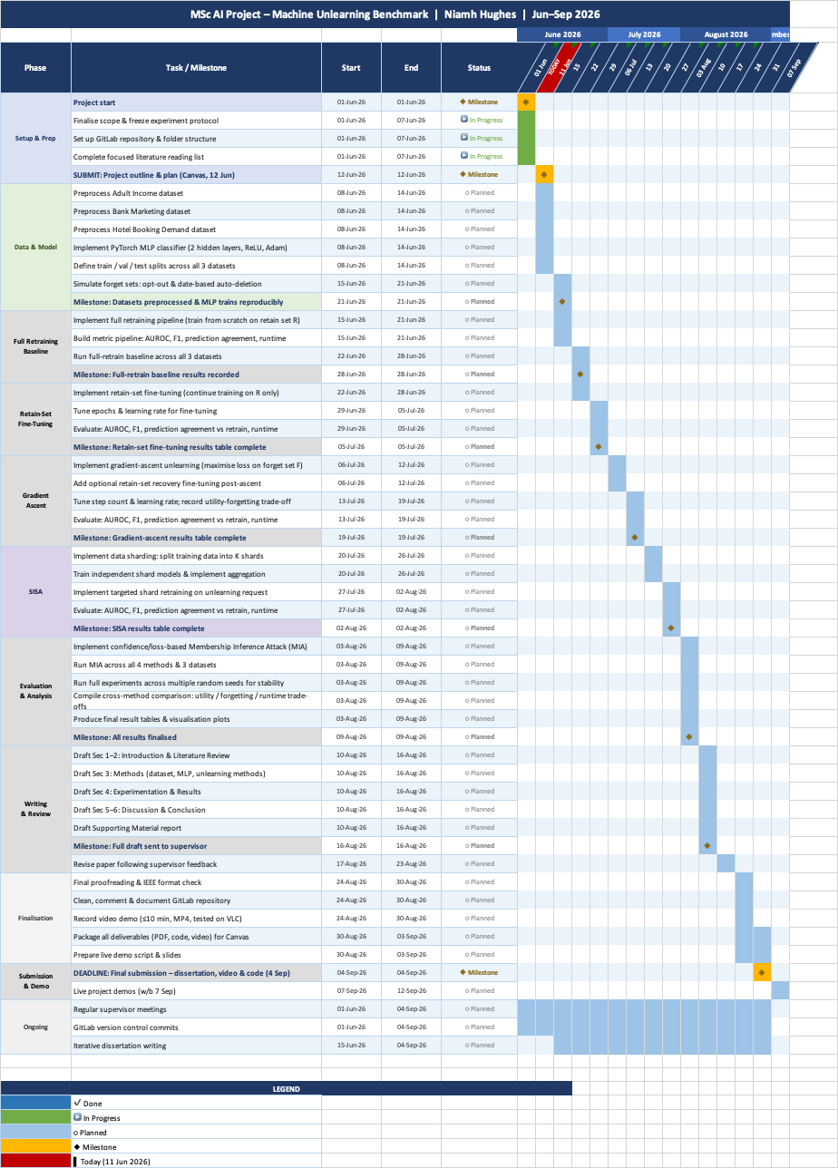
Appendix B: Gantt Chart

